# Critical Thinking & Problem-Solving

**Mike's 10 Ways to Stay Curious**

**Always challenge what you see and hear**

This is the hardest step because it isso easy to accept things the waythey are. But why is that? Forexample: if you don’t know how thedevice you are reading this ondisplays type and images, go findout...

**Focus on What Fascinates You**

If you literally question everythingyou won’t have time to live. So focuson the things that fascinate you. Forexample: I’m fascinated by design,unusual shapes and the quirks ofhuman nature. Therefore I tend toreally dive into these things. It’s alsowhy my Instagram feed tends tohave images of a lot of this stuff

**Try Something New**

A reasonable starting goal might beto try to learn something new ortaste a new food once a week. Butonce you get into this curiosity thing,aim for one new experience per day.It really stimulates your brain.

**Learn How to Ask Good Questions**

“Why” and “How” are simple startingquestions, but think of questions thatgo a bit deeper. For example: “Whatcauses the sky to be red in themorning before bad weatherarrives?”

**Ask People not Google**

Yes you can get answers to anythingon the web, but what you read therewill not stick with you the same waya conversation with a real personwill. The in-person query can alsolead to unexpected places -something a web search seldomdoes - or at least in a surprising andinteresting way.

**Become Perceptually Curious**

Instead of just finding intellectual answers to your questions, look forphysical experiences. Ever wonder how something is made? Find a wayto make it yourself or volunteer tohelp someone who knows how.

**Vanquish Boredom**

The act of being bored simply meansyou’re not paying real attention tothe world around you. For example:even waiting in the doctors office isfull of opportunity to catchinteresting snippets of conversation,hear words you can later research oreven to browse a magazine youwould otherwise have no otherreason to look at. All of this is greatfodder for curiosity.

**Be Conscientious**

That’s right, work hard and stay ontask to ensure you get each taskdone in a way you’d want, to beproud of your work. Some researchindicates the conscientious amongus are more likely to be curious andmore likely to be successful.

**Get Some Exercise**

The connection between a healthybody and an active mind is well-documented. The difference withcuriosity is that during a strenuouswalk or time at the gym you can letyour mind wander, alight on a topicand give it some deeper thought.Turn it over in your mind while thebody is otherwise occupied.

**Stay Vigilant**

It’s easy to let things slide; let thecuriosity flame dim. The danger isthat this is a slippery slope andbefore you know it, you’re driftingthrough life with a ho-hum attitude.This is deadly for your curiosity andit becomes a self-fulfilling prophesywhere you lack the very thing thatcan get you back on track - curiosity!

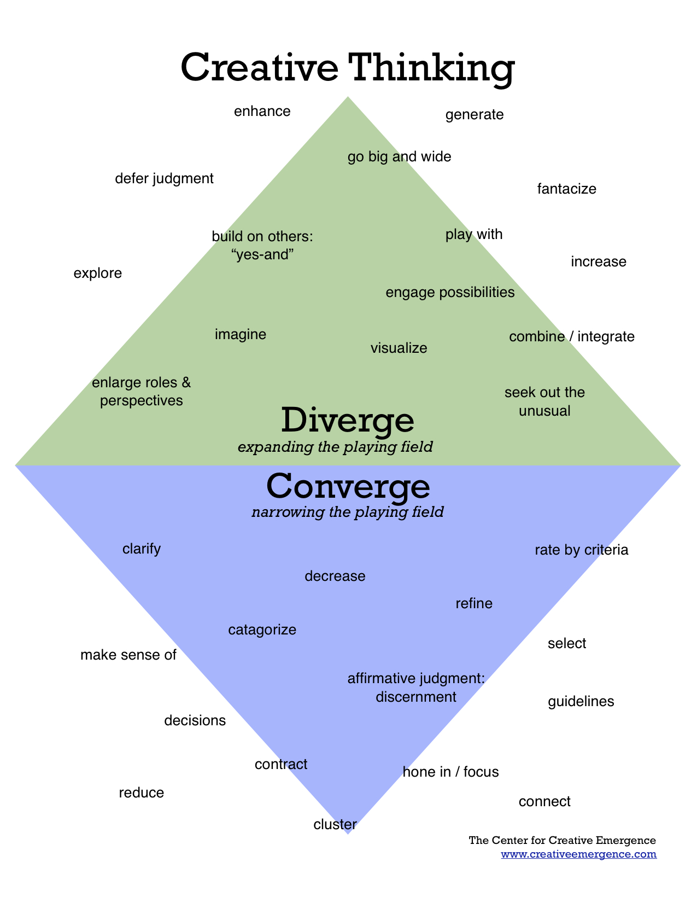

### 9 Thinking Behaviors...

|  |  |  |
| --- | --- | --- |
| CLARITY *You have added detail and examples.*  * Could you elaborate? * Could you illustrate what you mean? * Could you give me an example? | ACCURACY *Your thinking has facts and research to back it up.*  * How could we check on that? * How could we test that? * How do we know this is true? | PRECISION *Your thinking is specific and exact.*  * Could you be more specific? * Could you give more details? * Could you be more exact? |
| RELEVANCEYour thinking is directly related to the central idea, problem or question you are working on.  * How does this relate to the problem? * Does this answer the question? * How does this help us? | DEPTHYou have predicted difficulties or problems with your thinking. You imagine what could go wrong and what you could do about it.  * What will make this difficult? * Have you predicted different possible outcomes? * Have you looked ahead? | BREADTHYou have considered other points of view.  * Do you need to look at this from another perspective? * Do you need to consider other points of view? * Do you need to look at this in another way? |
| LOGICYou show your thinking in a way that make sense to others.  * Does all this make sense together? * Does your thinking follow the evidence? | FAIRNESSYou are aware of the thoughts and ideas of others. You do not ignore facts that disagree with your thinking. You are open to changing your mind.  * Am I considering the thinking of others? * Is my purpose fair in this situation? * Is my thinking based on facts or just opinions? | SIGNIFICANCEYour thinking is important to the central idea, problem or question you are working on.  * Which of these facts are the most important? * Is this the most important thing to consider? * Are you focusing on the most important thing? |

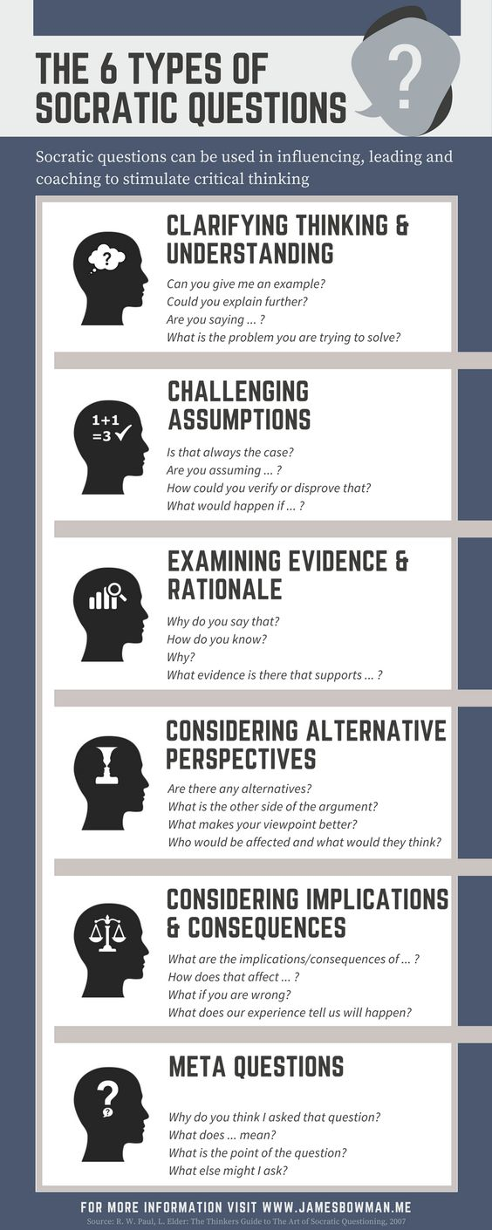

Questions on critical thinking:

* **Who said it?** … Someone you know? Someone in a position of authority or power? Does it matter who told you this?
* **What did they say?** … Did they give facts or opinions? Did they provide all the facts? Did they leave anything out?
* **Where did they say it?** … Was it in public or in private? Did other people have a chance to respond an provide an alternative account?
* **When did they say it?** … Was it before, during or after an important event? Is timing important?
* **Why did they say it?** … Did they explain the reasoning behind their opinion? Were they trying to make someone look good or bad?
* **How did they say it?** … Were they happy or sad, angry or indifferent? Did they write it or say it? Could you understand what was said?

### Top Barriers to Critical Thinking

* **Ego** – This is self-centered thinking and includes self-interested thinking and self-serving bias.   
  It is when it can be hard to see beyond how a particular issue or problem affects you personally.
* **Group think** – This is group-centered thinking and is when we tend to want to conform to what others think and as a result we suffer from group bias.
* **Assumptions** – These are our beliefs that we hold to be true without sufficient evidence or justification for holding these ideas.   
  This also includes what we call stereotyping or thinking that because one person or idea is a certain way that all such people or ideas are the same.
* **Wishful thinking** – Believing that something is true simply because deep down we wish it were true.
* **Relativism** – The way we can dismiss an idea because the truth "is just a matter of opinion."   
  This can be because the truth is different from what we "know" to be true or because the new truth is outside of our own experience or culture.   
  This can also be expressed as a fear of change.
* **Confirmation bias** – This is when we are not inclined to accept a new idea or truth because it doesn't conform to our own thinking.   
  In extreme cases it can be a fear of embarrassment or needing to save face because the truth is in direct opposition to an idea you have publicly expressed.
* **Poor communication** – This is when you either are incapable or choose not to communicate with all key stakeholders who will be affected by a decision. This likely means you don't have all the information you could have to critically think ahead of making a good decisions

Questions

What is the truth?

Who do you trust? Why?

Where do you get the information that forms your worldview? Why?

Do you reach conclusions and judgments based upon your ability to gather, evaluate and determine the relevancy and reliability of facts and evidence?

Can you tell truth from a lie? How do you do this?

Can you recognize "what really is" from what you believe "ought to be?"

Which barriers are most common in your critical thinking process and which ones do you see in others?

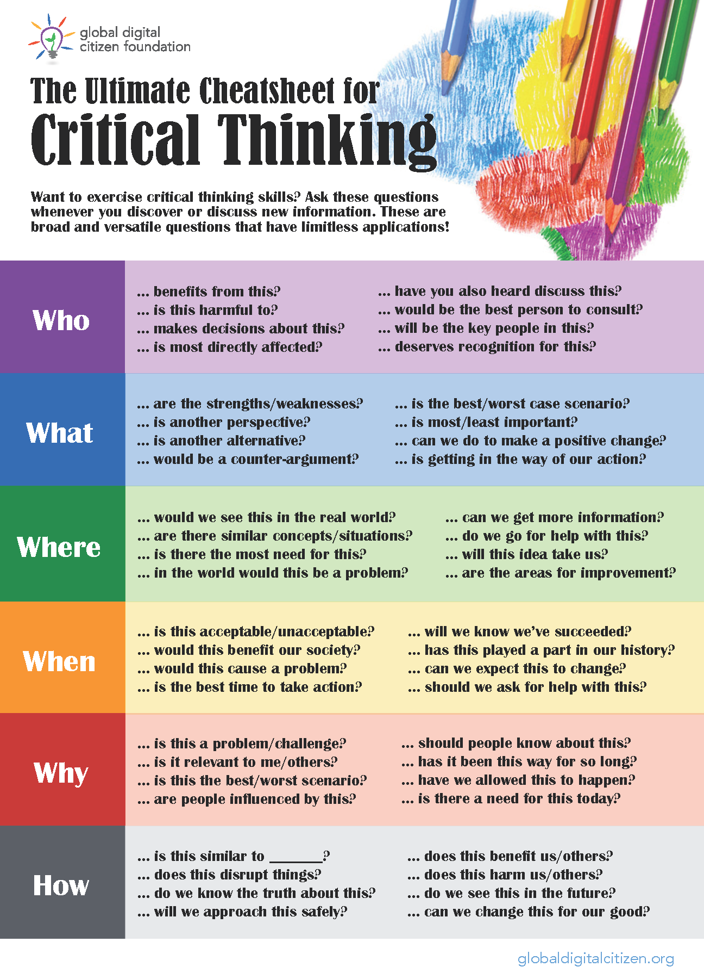

### Types of situations where critical thinking can be applied:

* -analyzing and explaining risks
* -designing & implementing initiatives
* -allocating resources
* -anticipating & preventing errors
* -analyzing markets
* -using & managing information systems
* -assessing opportunities & competition
* -evaluating the effects of initiatives
* -identifying & analyzing emergent concerns
* -developing data security protocols
* -evolving long term goals and plans
* -communicating effectively with team members
* -evaluating customer service
* -anticipating the implications of actions taken
* -hiring and promoting leaders
* -analyzing and resolving personnel issues
* -explaining policy and procedures
* -designing & evaluating departmental reports

